

Project: Shah Sachal Sami aein USAID Jo pegam: “Karyo Ilam Khe Aam”

By Small Grants and Ambassador’s Fund Program, USAID Pakistan Implemented by Shah Sachal Sami Foundation, Nawabshah
SUCCESS STORY
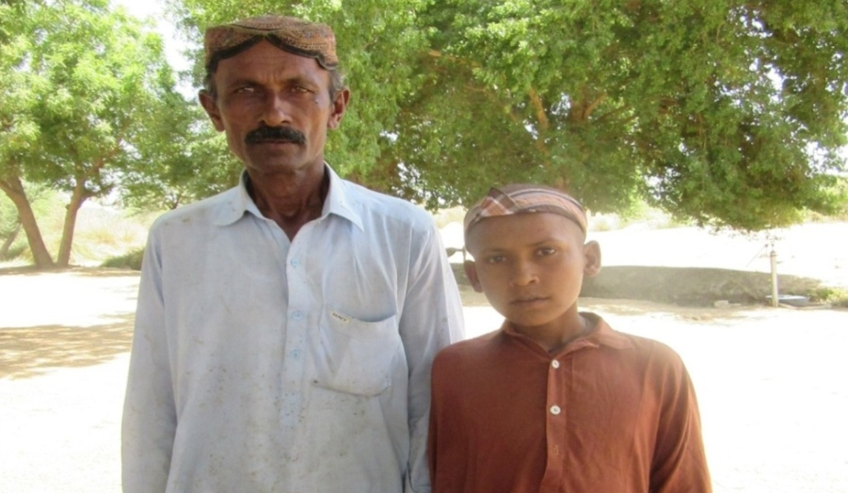
Raja, 9 years old, is the first ever child in his four generations from his family to have been enrolled in a school and started to obtain education under the Shah Sachal Sami aein USAID jo pegam “Karyo Ilm Khy Aam Project”. Raja, son of Shahmor Shahi, has been enrolled in class Katchi at Government Boys Primary School Khar, Union Council Khar by Ilm-Ambassador Hafiz Qurban Ali. Raja lives in a village Khar with his parents who have been living in the village for 50 years. His parents come from underprivileged segment of the society who were never approached before by any to educate them about the importance of education and sense of ownership in connection to education and children, further they always employed poverty as the main obstacle in educating their children.

However when Shah Sachal Sami Foundation’s project team started to implement the “Karyo Ilm Khy Aam Project” funded by Small Grants and Ambassador’s Fund Program in UC Khar, the project team conducted meeting with community in order to identify and select the prospective Ilm-Ambassadors from the village. Afterwards the Ilm-Ambassadors were capacitated on mobilization skill, communication skill, and in other areas in one day training so as they could reach out and engage such as Raja’s parents to persuade them to enroll their children in the schools.

In this connection, Ilm-Ambassador of project Shah Sachal Sami aein USAID jo pegam “Karyo Ilm Khy Aam Project” Hafiz visited the household of Shahmor Shahi and identified the 9 years old Raja as the out of school children nevertheless Shahmor was howled to the idea of educating his children and refuted to enroll the children in the school. However after organization of education awareness walk, education awareness theaters combined with frequent visits by Ilm-Ambassadors, Raja’s father finally came to realize the importance of education to ensure better future of children and better aware of their rights as a result Raja has become the child who has been able to break the cycle of illiteracy, which was ongoing for decades. He is now attending school regularly.
“Education is the path of success and betterment so they will continue will work-hard to continue to obtain the education regardless of the hardships they would have to face”

Now Raja’s father supports his son in his bid to acquire education with zest and zeal. He and Raja shared that now that they have become aware of significance of education and education is the path of success and betterment so they will continue will work-hard to continue to obtain the education regardless of the hardships they would have to face.

This project has been funded by the American people through the U.S. Agency for International Development under the Small Grants and Ambassador's Fund Program.

